PROJECT DOCUMENTATION

PROBLEM UNDERSTANDING IN THYROID DISEASE

Thyroid is most common problem that involved abnormal production of thyroid hormones. Thyroid disorder can affect heart rate, mood, energy level, metabolism, etc…

There are two types of possibilities of occurring:

1.HYPOTHYROIDISM

Hypothyroidism, also called underactive thyroid, is when the thyroid [gland](https://www.niddk.nih.gov/Dictionary/G/gland) doesn’t make enough thyroid [hormones](https://www.niddk.nih.gov/Dictionary/H/hormone) to meet your body’s needs. The thyroid is a small, butterfly-shaped gland in the front of your neck. Thyroid hormones control the way your body uses energy, so they affect nearly every organ in your body, even the way your heart beats. Without enough thyroid hormones, many of your body’s functions slow down.

2.HYPERTHYROIDISM

Hyperthyroidism, also called overactive thyroid, is when the [thyroid gland](https://www.niddk.nih.gov/Dictionary/T/thyroid-gland) makes more thyroid [hormones](https://www.niddk.nih.gov/Dictionary/H/hormone) than your body needs. The thyroid is a small, butterfly-shaped gland in the front of your neck. Thyroid hormones control the way the body uses energy, so they affect nearly every organ in your body, even the way your heart beats. With too much thyroid hormone, many of your body’s functions speed up.

DATA COLLACTION & DATA PREPARATION:

Data Collection and Preparation encompasses all the methods by which data can be prepared and ingested into Adobe Experience Platform. As well as the ability to collect data to Adobe Experience Platform’s Edge Network and subsequent forwarding of data via Side forwarding to enterprise destinations.

Data preparation includes the mapping of source data to Experience Data Model (XDM) schema. It also includes performing transformations on data, including date formatting, field splitting/concatenation/conversions, and joining/merging/re-keying of records. Data preparation helps unify customer data to provide aggregated/filtered analysis, including reporting or preparing data for customer profile assembly/data science/activation.

Data preparation is the process of cleaning and transforming new data process to processing and analysis.

EXPLORATORY DATA ANALYSIS

The thyroid is a butterfly-shaped gland located in the front of the neck just below the Adams apple formed by two wings (lobes) represented by the left and right thyroid lobes, it’s a biggest gland in the neck which is placed in the anterior neck. This gland produces thyroid hormones. These hormones help to regulate the body's metabolism and effects processes, such as growth and other important functions of the body.

**Exploratory data analysis is a way to better understand your data which helps in further Data preprocessing**. And data visualization is key, making the exploratory data analysis process streamline and easily analyzing data using wonderful plots and charts.

Correlation Analysis is super useful when you want to understand the relationship among variables (columns). Consider the following chart. Revenue is assigned at X-Axis and Profit is assigned at Y-Axis, and we are looking at how they are correlated.

**Correlation Analysis**

There are two ways to perform the correlation analysis with the algorithm. One is to find the correlation among the categorical values, such as regions. Another is to find the correlation among the columns (or variables), such as Revenue, Profit, and Expense. Let’s take a look one by one.

Thyroid data set is collected from UCI responsitory. The dataset contain 3 classes and 215 samples.

Pre-processing all the null and duplicate values has been removed from dataset.

MODEL BUILDING

Thyroid disease was acknowledge some recent book on internal medicine have begun to report some of the newly identified thyroid diseases.

**The six steps to building a machine learning model include:**

* Contextualise machine learning in your organisation.
* Explore the data and choose the type of algorithm.
* Prepare and clean the dataset.
* Split the prepared dataset and perform cross validation.
* Perform machine learning optimisation.
* Deploy the model.
* 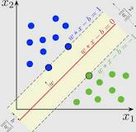
* SVC, or Support Vector Classifier, is **a supervised machine learning algorithm typically used for classification tasks**. SVC works by mapping data points to a high-dimensional space and then finding the optimal hyperplane that divides the data into two classes.
* 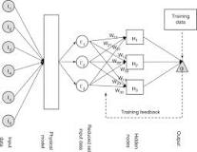
* ANN models are **the extreme simplification of human neural systems**. An ANN comprises of computational units analogous to that of the neurons of the biological nervous system known as artificial neurons. Mainly, the ANN model constitutes of three layers, viz., input, hidden, and output.
* **Unit tests.** The program is broken down into blocks, and each element (unit) is tested separately.
* **Regression tests.** They cover already tested software to see if it doesn’t suddenly break.
* **Integration tests.** This type of testing observes how multiple components of the program work together.

PERFORMANCE TESTING & HYPERPARAMETER TUNING

Thyroid function tests represent an important asset for physicians in the diagnosis and monitoring.

Artificial intelligence application have potential to optimize correct test prescription.

Hyperparameter Tuning

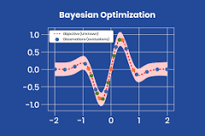

Hyperparameter tuning consists of **finding a set of optimal hyperparameter values for a learning algorithm while applying this optimized algorithm to any data set**. That combination of hyperparameters maximizes the model's performance, minimizing a predefined loss function to produce better results with fewer errors.

Performance Testing

Tuning is **the process of maximizing a model's performance without overfitting or creating too high of a variance**. In machine learning, this is accomplished by selecting appropriate “hyperparameters.” Hyperparameters can be thought of as the “dials” or “knobs” of a machine learning model.

MODEL DEPLOYMENT

INTRODUCTION

Artificial intelligence (AI) is a field of computing science mimicking the human thought processes and behaviours used to make decisions or take actions . It uses different mathematical and algorithmic approaches, from operational research to constrained programming .

Thyroid hormones are fundamental for development, neuronal growth, fertility, and metabolism . Thyroid diseases are frequent conditions, affecting millions of people around the world, related to multiple health problems and for which thyroid function tests (TFT) are frequently ordered for diagnosis and monitoring of diseases .

### **Impact on preanalytical factor and process optimization**

An important aspect within the preanalytical phase is the appropriate test ordering by physicians. Guiding the physicians for the ordering of the right TFT according to clinical context is important, especially in a context where the over-use of TFT has been documented in both hospital and primary care practices . The optimal choice of TFT is important to make effective clinical decision, to help physicians spend more time treating patients . In contrast, excessive TFT ordering policies can prompt financial weight in a period of rising medical care costs

Clinical laboratories are still in important phases of consolidation and automation, with emphasis placed also at the preanalytical levels and samples transportation. Clinical laboratories also constantly work on the improvement of patients’ experience and laboratory services.

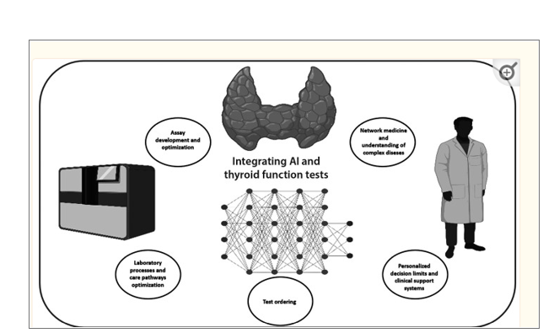

INTRODUCTION

Digital medicine has the capacity to affect all aspects of medicine, including disease prediction, prevention, diagnosis, treatment, and post-treatment management. In the field of thyroidology, researchers are also investigating potential applications of digital technology for the thyroid disease. Recent studies using artificial intelligence (AI)/machine learning (ML) have reported reasonable performance for the classification of thyroid nodules based on ultrasonographic (US) images.

KEYWORDS

Thyroid, Thyroid neoplasms, Hyperthyroidism, Hypothyroidism, Artificial intelligence, Machine learning, Database, Wearable electronic devices

DIGITAL MEDCINE

Digital medicine not only makes it possible to use digital devices for medical purposes, but also changes the overall landscape of disease prediction, prevention, diagnosis, treatment, and post-treatment management. Furthermore, it changes the ways in which medical providers and consumers communicate, use medical resources, and bill and pay for medical expenses.

DONE BY;

KEERTHANA.P

SAKTHI.M

TAMILSELVI.B

SANJALA.M

VIGNESHWARAN.B